Business Template

Subject areas
Logo / Image

Contents
1 Business Description 3
1.1 Business background 3
1.2 Problems. Current Situation 3
1.3 The benefits of implementing a database. Project Vision 3
2 Model description 3
2.1 Definitions & Acronyms 3
2.2 Logical Scheme 3
2.3 Objects 3

Business Description

Business background
I choose a online store. Users can buy prducts online and supliers can sell their products online. User can select product, confirm order, pay order and receive shipment. The store can save reviews for products from users/customers.

Problems. Current Situation
Information about products, customers, supliers may be store in separate excel files and it is difficult to orders. This may lead to duplicating of data and higher risk of inconsistency.

the Benefits of implementing a database. Project Vision
The DB will provide centralized and structured storage for all buisness data.This will reduce duplicating of data, improve consistency and simplify order management. The project vision is to build a scalable and reliable data model for an online store.

Model description

Definitions & Acronyms
PK – primary key, unique identifier of a record.
FK – foreign key, a column referencing a primary key in another table and connecting two tables.
1:N – one to many relationship
1:1 – one to one relationship
N:M – many to many relationship
3FN – third normal form

Logical Scheme

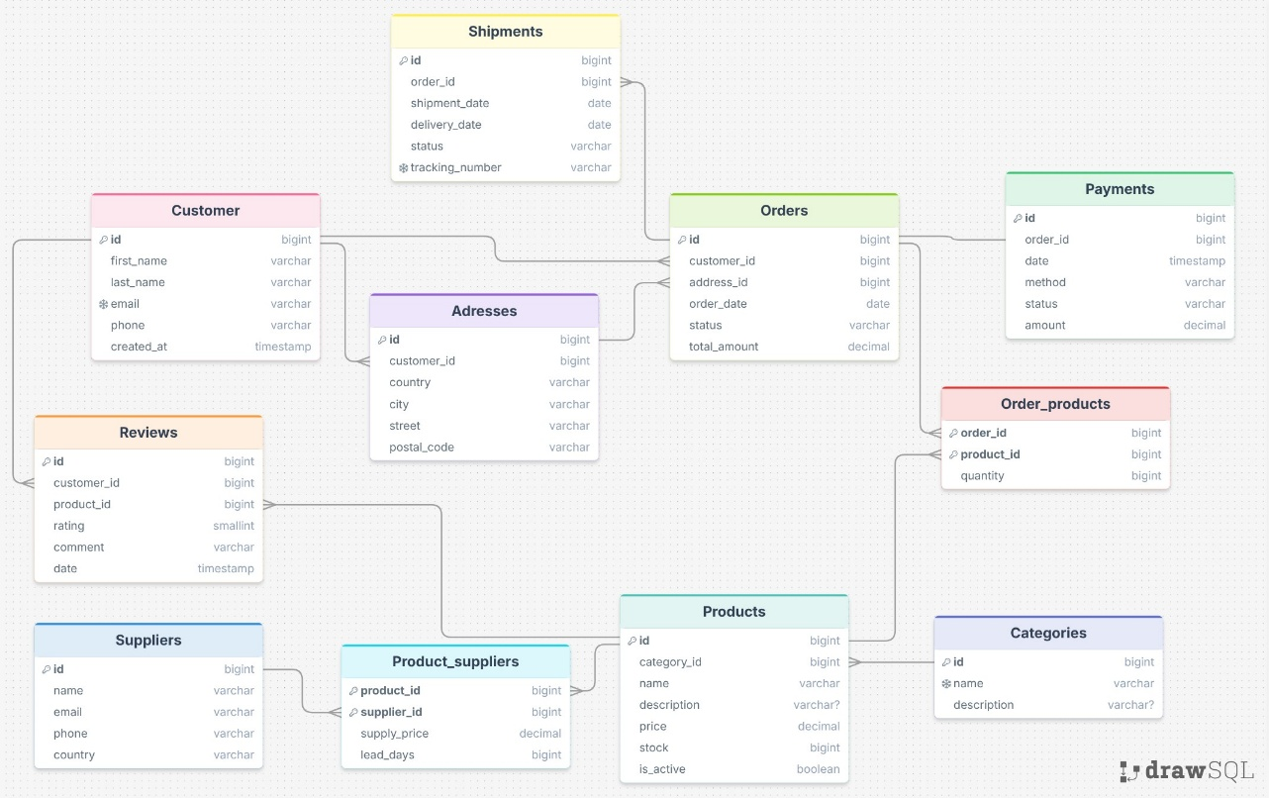

Objects

Table Description
This table store information about customer that registrated in the online store

Table Name | Field name | Field Description | Data Type
Customers | id | PK | Int
 | First_name | Customer first name | varchar
 | Last_name | Custom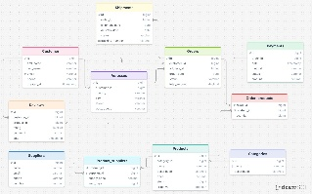er last name | varchar
 | Email | Customer email, Unique | varchar
 | Phone | Customer phone number | varchar
 | Created_at | Date and time when customer created accaunt | timestamp

One customer can have multiple adresses
One customer can place multiple orders
Custemer can leave reviews for products they purchased

Example with data

Customer_id | First_name | Last_name | Email | Phone | Created_at
1 | Nurdaulet | Tolegen | Nurdaulettolegen26@gmail.com | 87761585203 | 09.04.2026 15:00

Table Description
This table store information about products.

Table Name | Field name | Field Description | Data Type
Products | id | PK | Int
 | Category_id | FK, store info about category | Int
 | Name | Product name | varchar
 | Description | Description or product | varchar
 | Price | Price of product | decimal
 | Stock | Count of stock | int
 | Is_active | Product aviability | boolean

One order can have many products and product can be in many orders
Many products can have one category
One product can have many reviews

I was too lazy to write each table, you can see the rest of the tables in the picture at the top.:)
Other relationships:
One order can have one payment
One order can have many products
One category can have many products
One supplier can supply many products and one product can have many suppliers
One order can have many shipments

